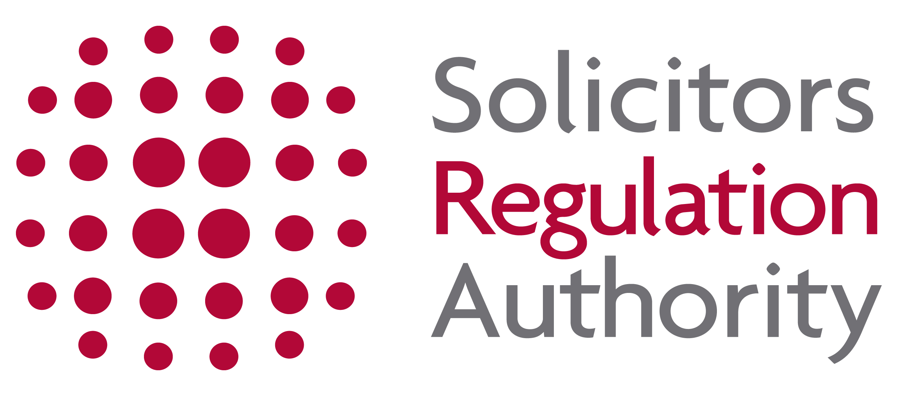
METHODS OF PAYMENT -
APPLICANTS WITH REASONABLE ADJUSTMENTS
(not for online applications)

Payment may be made using any of the following methods. Once completed, please send this form, together with your completed application form to the address below:

Solicitors Regulation Authority, The Cube, 199 Wharfside Street, Birmingham, B1 1RN, or DX 720293 BIRMINGHAM 47.

Payments direct from your bank

You may pay direct to the SRA’s bank account. All charges must be paid by the remitter and the remitter’s name and SRA number must be quoted as a reference.

Please complete the confirmation form and return it with your completed application once you have instructed your bank to make payment direct.

Bank Barclays Bank PLC
Account Number: 43577902
Sort Code: 20-32-29
Account Name: SRA
IBAN: GB53 BARC 2032 2943 577902 (overseas)
SWIFT: BARCGB22 (overseas)

APPLICATION TYPE:
VALUE:
DATE TRANSMITTED:
PAYMENT REFERENCE (please quote your SRA number & form type):
REMITTER'S NAME:

Payment by cheque

We do not accept payment via cheque unless prior arrangements have been agreed with us, therefore, all cheques received will be returned to sender unless prior arrangements have been agreed.

Cheques should be made payable to SRA.

